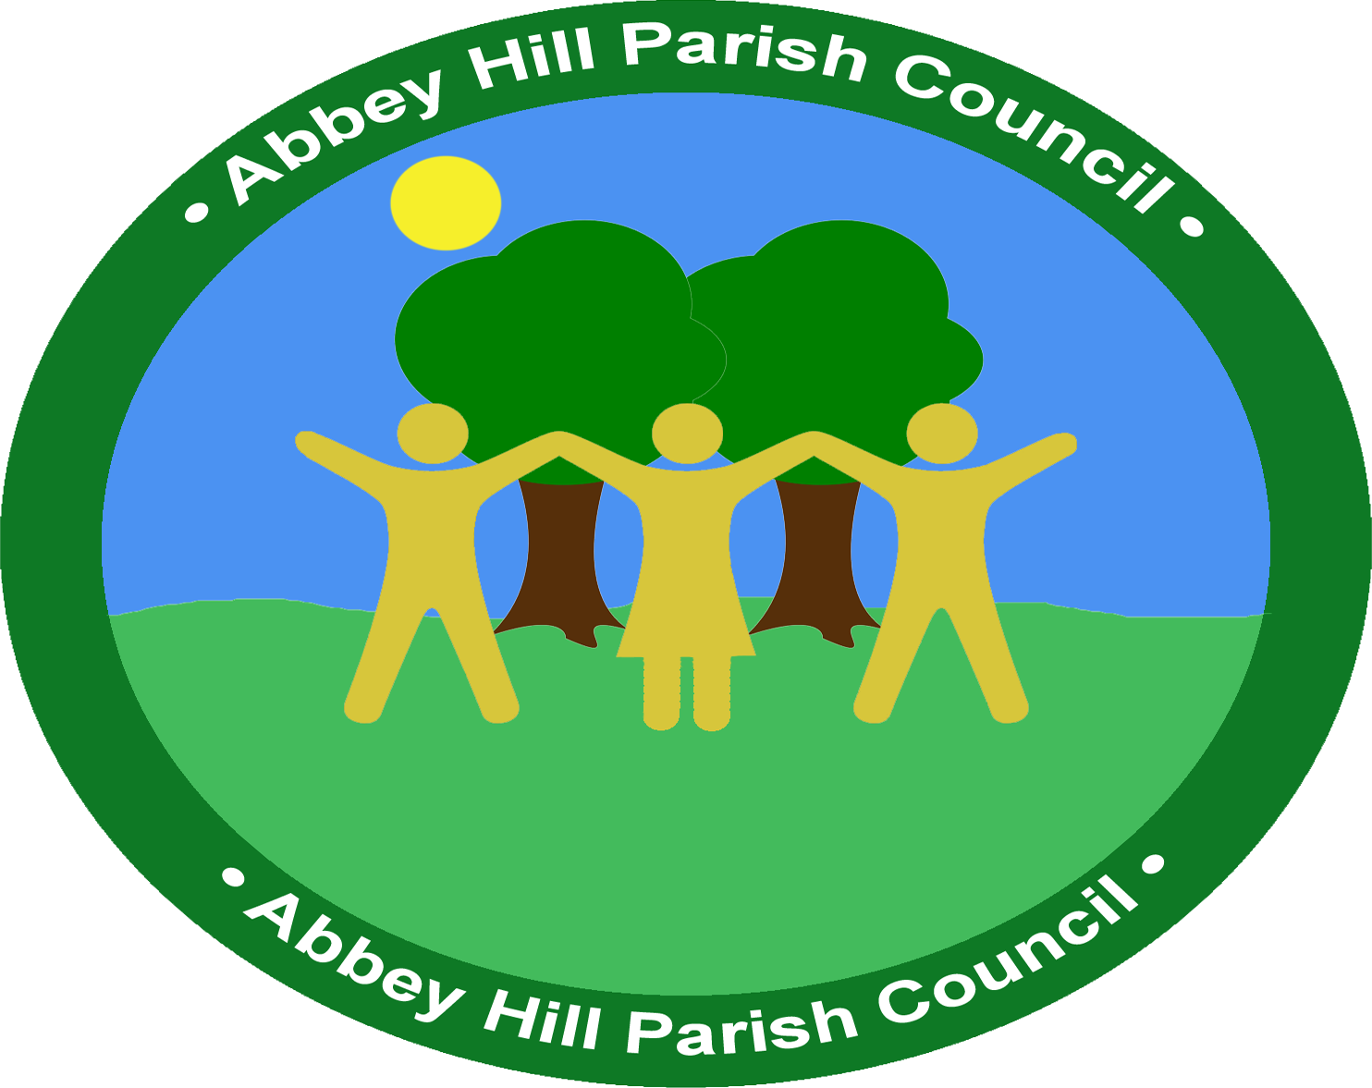

Summons to a Meeting of Abbey Hill Parish Council on Thursday, 12th June 2025 at 7.30pm at The Church of the Holy Cross, High Street MK8 8EQ
Councillors Blyth (Chair), Ryan (Vice Chair), Vine(AV), Pant (AP), Evans (AE) are summonsed to attend.

AGENDA

Members of the public are invited to attend Parish Council Meetings.
During the Public Forum, residents are welcome to raise matters of concern regardless of whether those topics appear on the Agenda

1. Chairman’s opening remarks
2. Apologies for absence
3. Declaration of Members’ Interest and application for dispensation.
4. To confirm the minutes of the Council meeting held on 12th June 2025
5. a) An opportunity for the public to speak
b) To receive verbal or written reports from our District Councillors
6. Community Projects
a) Coffee Mornings
b) MKPA Sessions
C) Consider Grant Application Request – Neighbourhood Watch
d) Active Travel – School Zone Proposal - To receive a presentation from Gareth Lewis regarding a proposal to apply for a School Zone in Two Mile Ash.
7. Finance
a) Consider reports for the financial position for the month ending June 2025
b) Approve upcoming payments in July 2025
8. Communications
a) Update on the Hire Agreement with Watling Valley Partnership
9. Update on alternative website
10 Environment & Assets
a) Update on goal post
b) Update on broken footbridge
c) Street sweeping/Weeds/Condition and maintenance of footpaths
d) Update on Glendale

11. Meetings
a) Receive and consider items for the next meeting
b) Confirm date of next meeting.
13. Correspondence
a) Flooding Survey
b) Letter received from Allotment Society
12. Planning
To consider any planning applications received.

Signed: | Cynthia Ondeng | 3rd July 2025 | Clerk and RFO

